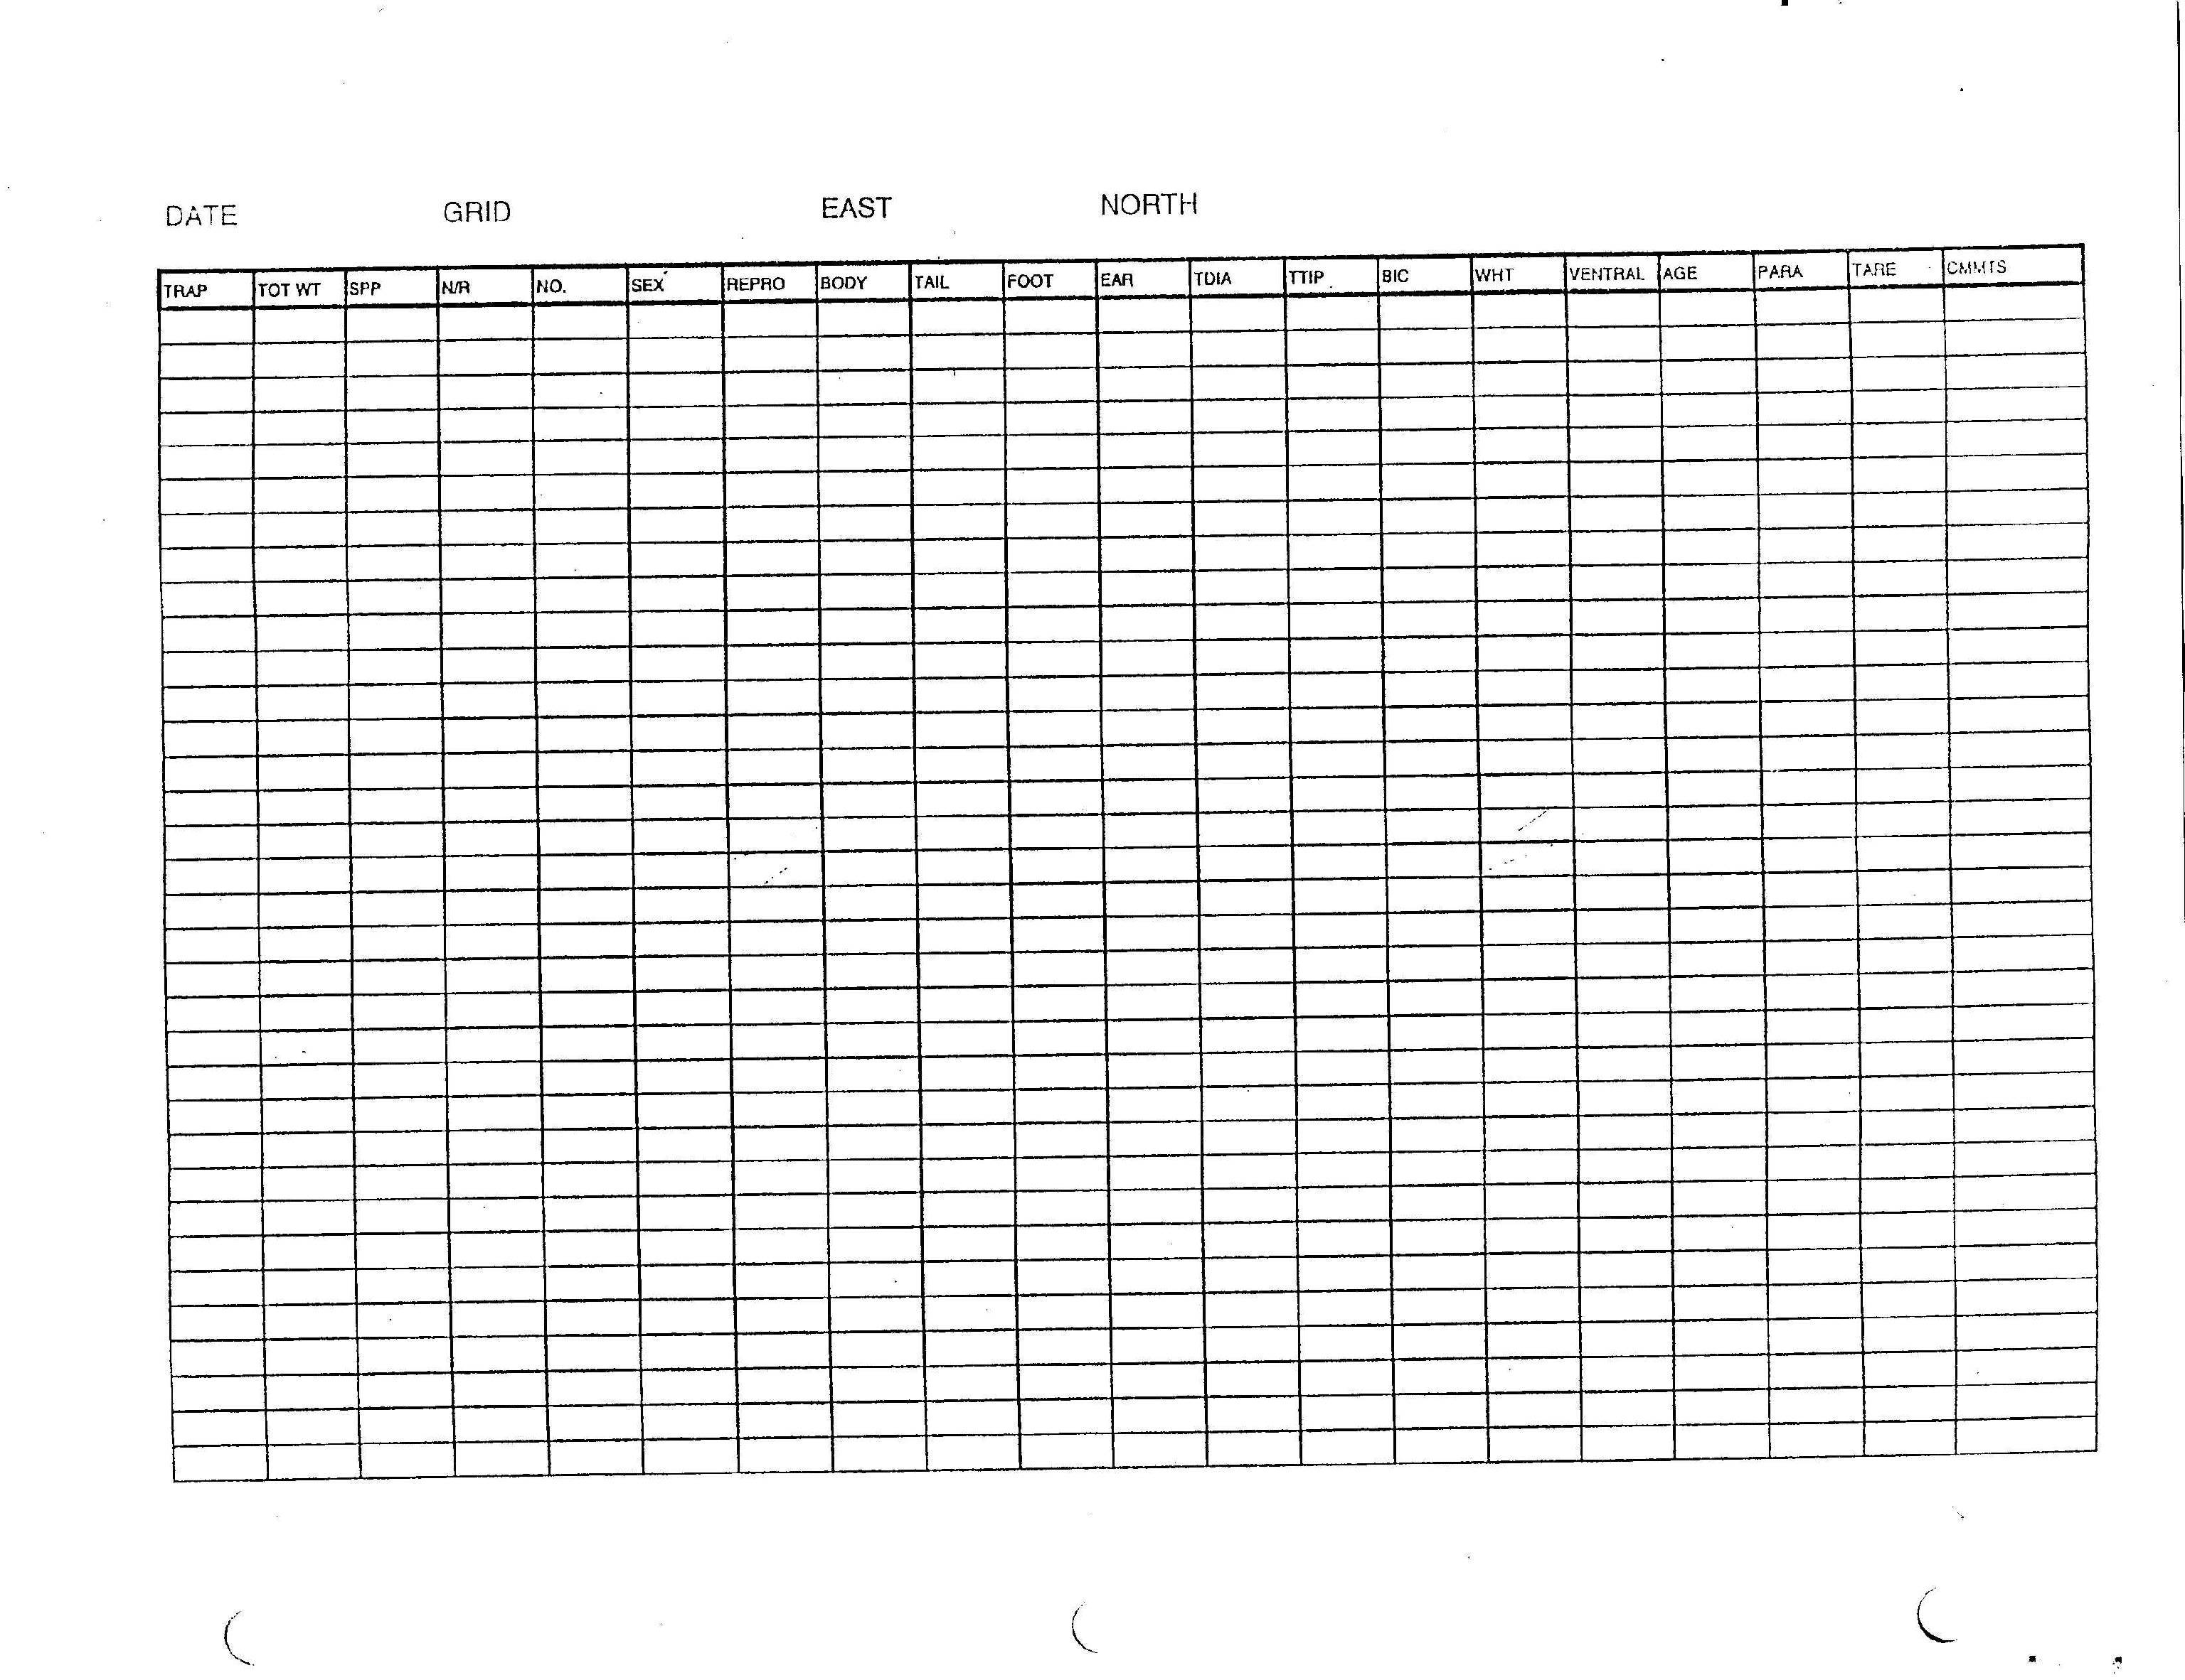

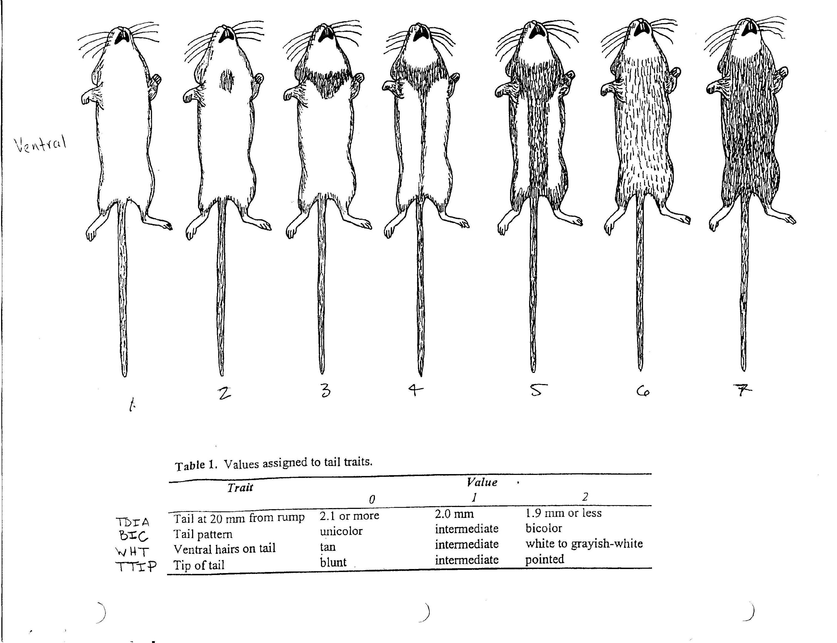
Figure 2. Characteristics key for Reithrodontomys raviventri (Shellhammer 1984).
Species
MICA | Microtus californicus
MUMU | Mus musculus
PEMA | Peromyscus maniculatus
RANO | Rattus norvegicus
REME | Reithrodontomys megalotis
RERA | Reithrodontomys raviventris
RESP | Reithrodontomys species
SOOR | Sorex ornatus
UNSP | unidentified species (escaped)
N/R
N | new capture
R | recapture
Sex | male (M)/female (F)
Repro
Males | S | scrotal
 | N | non-scrotal
 | A | abdominal
Females
 | P | pregnant
 | MD | mammaries developed
 | MG | mammaries developing
 | PL | post lactating
 | L | lactating
 | E | in estrus
 | N | non-reproductive
 | O | vaginal opening is open/swollen
 | C | vaginal opening is closed
Measurements (mm)
Body | body length
Tail | tail length
Foot | foot length
Ear | ear length
Age
J | juvenile
S | subadult
A | adult
Parasites/Disease
absent | 0
present | 1
Reithrodontomys |  |  |  |  | mm
TDIA | tail diameter at 20mm from base |  |  |  | 0-2
TTIP | shape of tail tip |  |  |  | 0-2
BIC | tail bicoloration |  |  |  | 0-2
WHT | ventral tail hair color |  |  |  | 0-2
Ventral | ventral hair color pattern |  |  |  | 0-7

